Responsive Web Design

Lab Book

Copyright © 2011 IGATE Corporation. All rights reserved. No part of this publication shall be reproduced in any way, including but not limited to photocopy, photographic, magnetic, or other record, without the prior written permission of IGATE Corporation.

IGATE Corporation considers information included in this document to be Confidential and Proprietary.

Document Revision History

|  |  |  |  |
| --- | --- | --- | --- |
| Date | Revision No. | Author | **Summary of Changes** |
| 05-June-2015 | 1.0 | Vaishali Kunchur | Initial Draft |
| 01-July-2017 | 2.0 | Rahul Vikash | Change as per BU |
|  |  |  |  |
|  |  |  |  |

Table of Contents

Document Revision History 2

Table of Contents 3

Getting Started 4

Overview 4

Setup Checklist for jQuery 4

Lab 1. Installation of Mocha 5

1.1: Installing MochaJS 5

Lab 2. Synchronous and Asynchronous Tests 8

2.1: Synchronous Test 8

TODO Assignments 8

Lab 3. Hooks 9

3.1: Working with Hooks 9

TODO Assignments 10

Lab 4. Exclusive and Inclusive Tests 11

5.1: Creating Exclusive test using .only 11

Lab 5. Working with MochaJS Reports 12

5.1: Using different Reporting options in MochaJS 12

Getting Started

## Overview

This lab book is a guided tour for learning jQuery. It comprises solved examples and ‘To Do’ assignments. Follow the steps provided in the solved examples and work out the ‘To Do’ assignments given.

## Setup Checklist

Here is what is expected on your machine in order for the lab to work.

Minimum System Requirements

* Intel Pentium 90 or higher (P166 recommended)
* Microsoft Windows XP or above.
* Memory: 256MB of RAM (512MB or more recommended)
* Internet Explorer 6.0 or higher

Please ensure that the following is done:

* A text editor like Notepad, Editplus
* NodeJS should be installed on your machine

1. Responsive and non-responsive web pages

|  |  |
| --- | --- |
| **Goals** | * Understand difference between Responsive Web page and a non-responsive Web page. |
| **Time** | 10 minutes |

## 1.1: Understand difference between Responsive Web page and a non-responsive Web page

**Step 1:** Open following web sites:

Popular web sites that you generally visit:

eg: <http://www.amazon.com/>

google.com

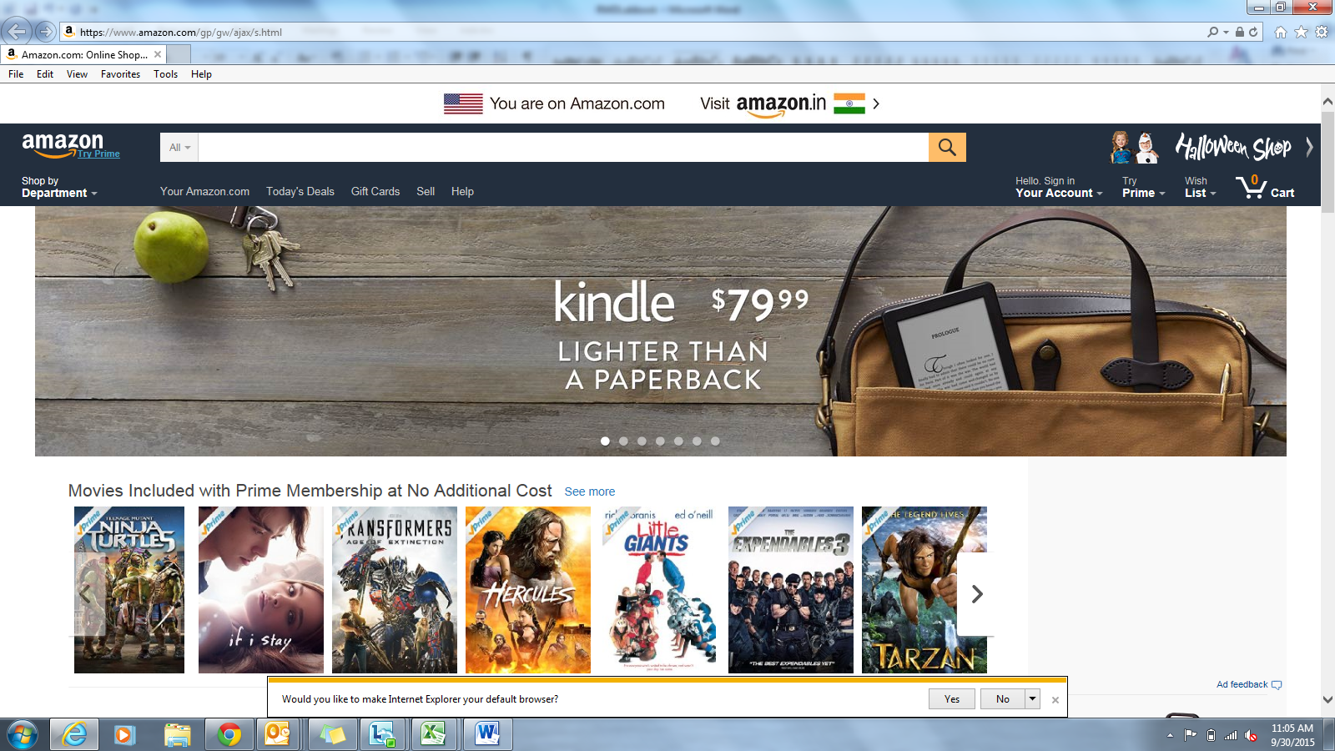

After resizing, the images/ contents get cut as shown below

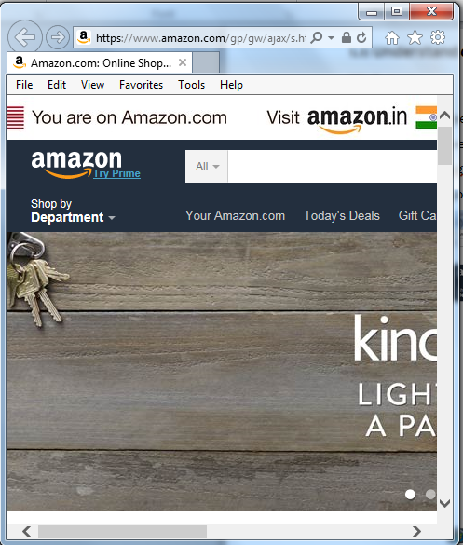

**Step 2: Resize these pages and see if the contents of the web page are getting resized. If not them they are non-responsive web pages**

**Now open following web sites:**

[**http://www.headlondon.com**](http://www.headlondon.com)

[**http://css-tricks.com**](http://css-tricks.com)

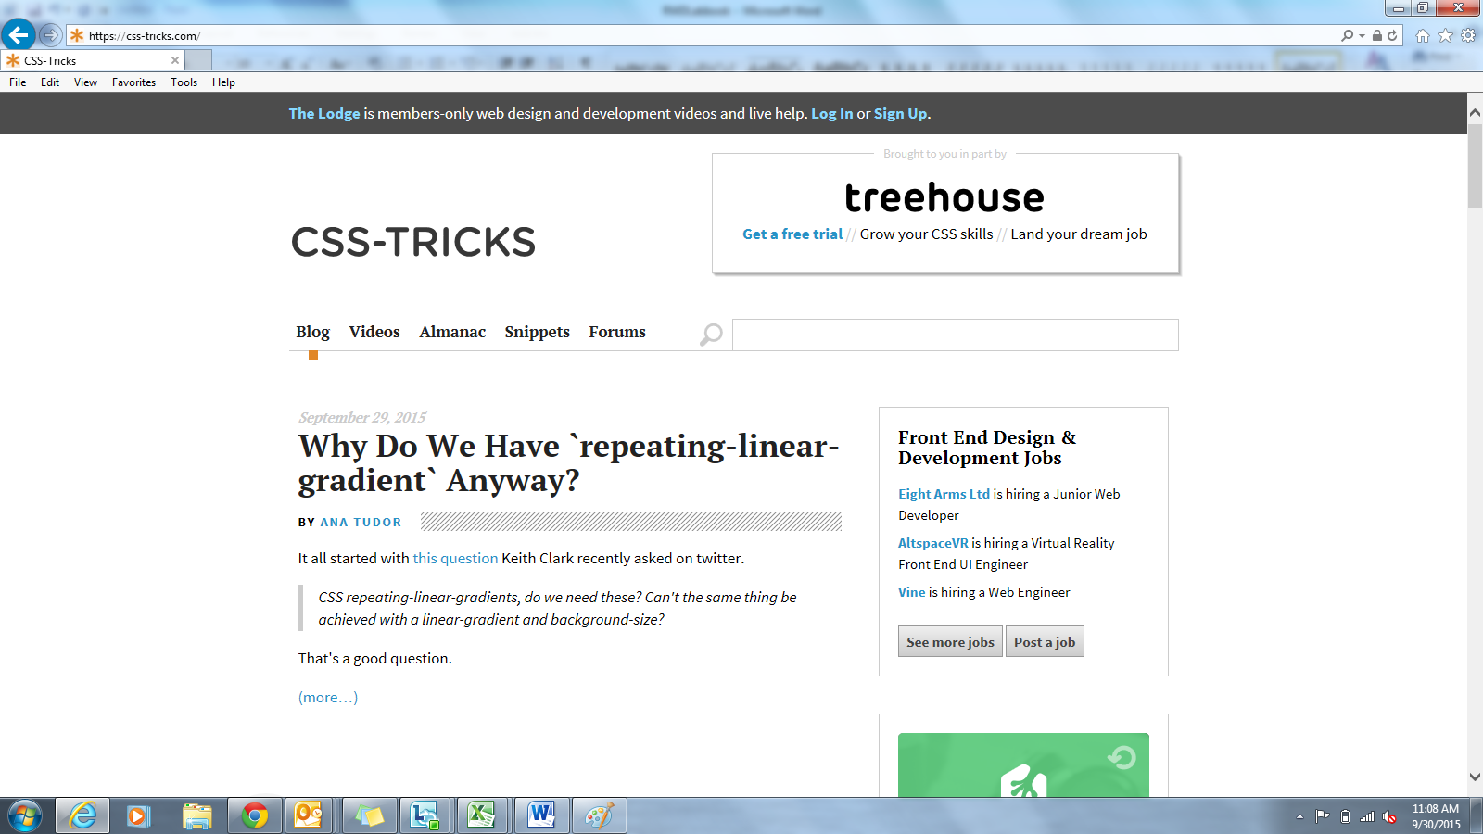

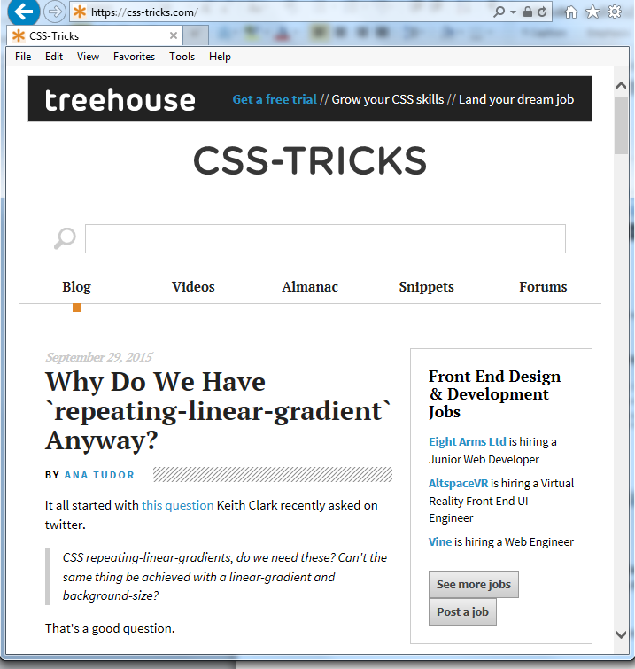

**Now observe these web pages and see that the contents of the web page are getting resized when you resize these pages. This means that they are responsive web pages.**

1. Flexible Grid Demo

|  |  |
| --- | --- |
| **Goals** | * Flexible Grid Demo |
| **Time** | 20 minutes |

## 2.1: Open Editor

**Step 1:** Create a New Web page and write following code.

**Step 2:** It should have files as shown in figure below:

<HTML>

<HEAD>

<TITLE></TITLE>

<style>

.container **{**

width**:** 52.5390625%**;**/*538px ÷ 1024px =1*/

height**:**7.43494423791822%**;**/*40px ÷ 538px =.0743494423791822*/

background-color**:**Gray**;**

**}**

section**,**

aside

**{**

margin**:**0.92936802973978%1.85873605947955%0.92936802973978% 1.85873605947955%;/*10px ÷ 538px = 0.0185873605947955 and 0.0092936802973978*/

text-align:center;

}

section {

float: left;

background-color:Lime;

width: 63.197026%;/* 340px ÷ 538px = .63197026 */

}

aside {

float**:** right**;**

width**:** 29.3680297%**;** /* 158px ÷ 538px = .293680297 */

background-color**:**Lime**;**

**}**

</style>

</HEAD>

<BODY>

<divclass="container">

<section>**Section**</section>

<aside>**Aside**</aside>

</div>

</BODY>

</HTML>

**Step 3:** In sync.js write following code:

**Step 3:** Open this web page in web browser.

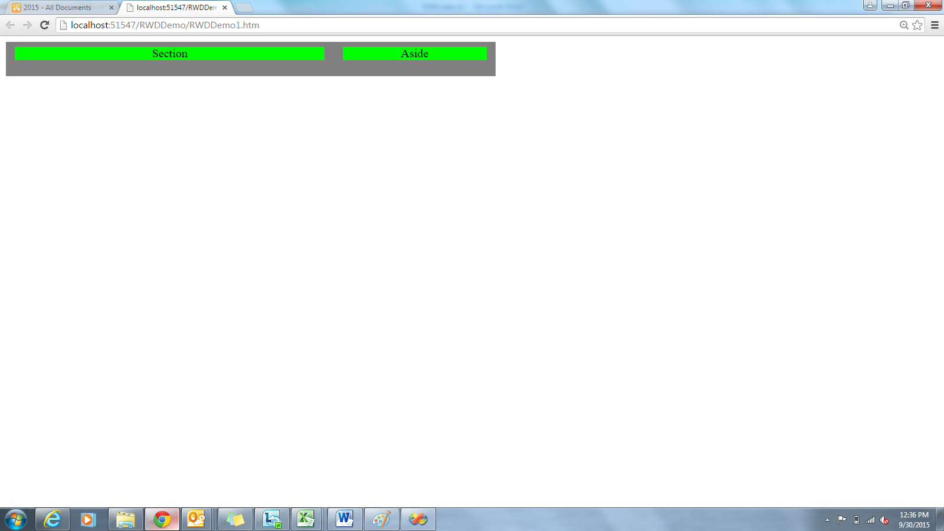

**Step 4:** Reduce the size of this web page.

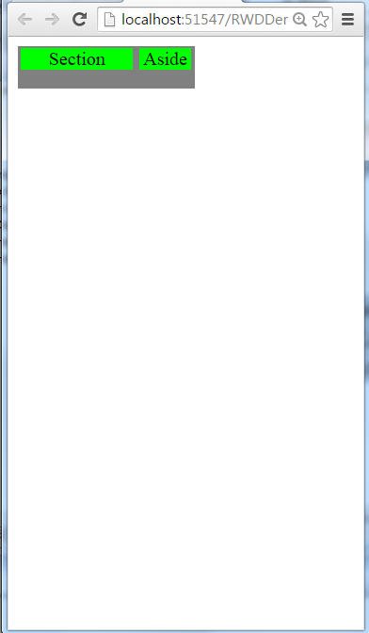

## 2.2: Create a web page:

<HTML>

<HEAD>

<METANAME="GENERATOR"Content="Microsoft Visual Studio 8.0">

<TITLE>**Another RWD example**</TITLE>

<style>

#page

**{**

margin**:**36pxauto**;**

width**:**90%**;**

background-color**:**Gray**;**

**}**

.blog

**{**

margin**:**0auto53px**;**

background-color**:**Gray**;**

width**:**93.75%**;**/*900px/960px*/

**}**

.main

**{**

float**:**left**;**

width**:**62.88888889%**;**/*566px/900px*/

background-color**:**Lime**;**

text-align**:**center**;**

**}**

.other

**{**

float**:**right**;**

width**:**36.77777778%**;**/*331px/900px*/

background-color**:**Lime**;**

text-align**:**center**;**

**}**

</style>

</HEAD>

<BODY>

<divclass="blog">

<divclass="main">

Main content

</div>

<div class="other">

other

</div>

</div>

</BODY>

</HTML>

**Step 3:** Open this web page in web browser.

**Step 4:** Reduce the size of this web page.

1. Responsive Image

|  |  |
| --- | --- |
| **Goals** | * Responsive Image |
| **Time** | 20 minutes |

## 3.1: Responsive Image

**Step 1:** Create a web page with following code

<!DOCTYPEhtml>

<html>

<head>

<metaname="viewport"content="width=device-width, initial-scale=1.0"/>

<style>

.figure **{**

display**:** block**;**

overflow**:** hidden**;**

margin-bottom**:** 0**;**

width**:** 112.272727%**;** /* 741px / 660px */

**}**

img

**{**

max-width**:**50%**;**

**}**

</style>

</head>

<body>

<divclass="figure">

<b><imgsrc="Tulips.jpg"alt=""/></b>

<divclass="main">

<h1>You can never be too sure.</h1>

</div><!-- /end .main -->

</BODY>

</HTML>

## 

1. Media Query

|  |  |
| --- | --- |
| **Goals** | * Understand and use of Media Query |
| **Time** | 20 minutes |

## 4.1: Using Media Query

**Step 1:** Create web page and write following code

<!DOCTYPE HTML>

<HTML>

<HEAD>

<METANAME="GENERATOR"Content="Microsoft Visual Studio 8.0">

<TITLE>**Media QUery Demo**</TITLE>

<script>

var **mq = window.matchMedia(**"(min-width:500px)"**);**

if**(mq.matches){**

**alert(**"device width is at least 500px"**);**

**}**

else**{**

**alert(**"device width is less then 500px"**);**

**}**

</script>

<style>

body

**{**

background-color**:**Gray**;**

**}**

@media **screen and (max-width:400px)**

**{**

h1

**{**

color**:**green**;**

**}**

**}**

@media **screen and (max-width:960px)**

**{**

body

**{**

background-color**:**Red**;**

**}**

**}**

@media **screen and (max-width:768px)**

**{**

body

**{**

background-color**:**Yellow**;**

**}**

**}**

@media **screen and (max-width:320px)**

**{**

body

**{**

background-color**:**Blue**;**

**}**

**}**

</style>

</HEAD>

<BODY>

<h1>**Demo for Media Query**</h1>

<divclass="blog">

<p>**Resize browser window to see media queries working....**</p>

<p>**Resize browser window to see media queries working....**</p>

<p>**Resize browser window to see media queries working....**</p>

<p>**Resize browser window to see media queries working....**</p>

<p>**Resize browser window to see media queries working....**</p>

<p>**Resize browser window to see media queries working....**</p>

<p>**Resize browser window to see media queries working....**</p>

<p>**Resize browser window to see media queries working....**</p>

</div>

</BODY>

</HTML>